

**(Established under the Presidency University Act, 2013 of the Karnataka Act 41 of 2013)**

**Course Code : CSE1006 Course Title : Problem solving using java**

**Labsheet -1**

1. A teacher in a school wants to calculate the average marks of a student in three subjects to assess their overall performance. Help the teacher to develop a program that accepts the marks of three subjects and calculates the average.

**Java Code:**

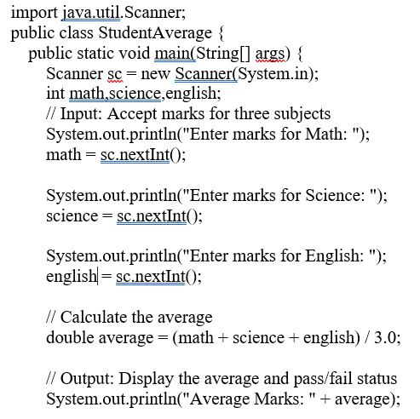

// Close the scanner, it requires when VS code compiler is used

scanner.close();

}

}

===================

**Naming conventions in java:**

**PascalCase (Upper Camel Case)**

In PascalCase, each word in the identifier is capitalized, including the first one.

PascalCase is primarily used for naming classes and interfaces in Java.

Example include Factorial, EmployeeTax and SumOfTwoNumbers

**camelCase (Lower Camel Case)**

camelCase is similar to PascalCase, but the first letter of the first word is in lowercase. It’s commonly used for naming variables and methods.

Examples include customerService, marksInMaths, studentProfile and employeeTax()

1. Presidency University collect student information during enrollment for the even semester. The program uses the Scanner class to take input (such as name, age, marks and gender) from the student and displays the information entered. Help the Presidency University by writing an application in java to perform the same. (Hint: Use Scanner Class to take the Input from the User)

**Java Code:**

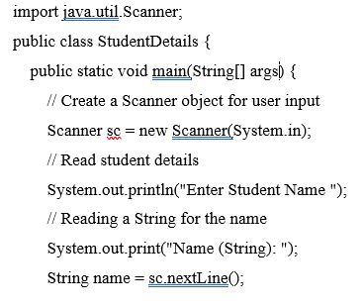

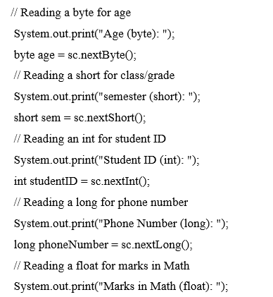 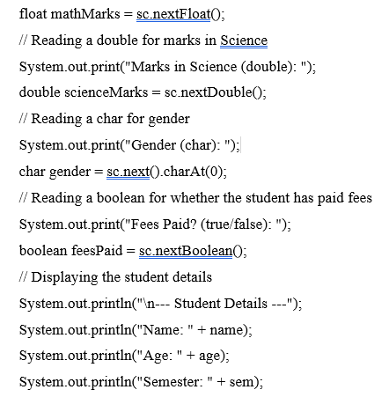

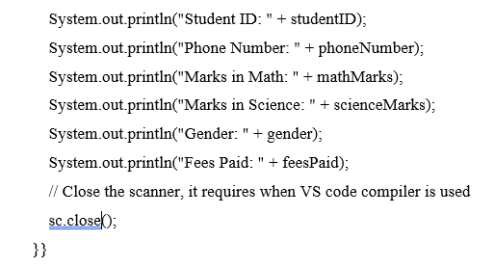

========================

// above program can also be written by assigning values to the variables as below

public static void main(String[] args) {

// Assigning student details using all data types

String studentName = "Zoya Hussain"; // String for textual data

int studentID = 123; // int for unique student ID

byte age = 20; // byte for age (small range)

char grade = 'A'; // char for grade

float percentage = 89.75f; // float for percentage

double attendance = 92.345; // double for attendance (higher precision)

long contactNumber = 9876543210L; // long for contact number

short yearOfEnrollment = 2023; // short for enrollment year

boolean isEnrolled = true; // boolean to check enrollment status

=======================

1. Demo program on Command line arguments.
   1. Type the below program with file name **Cities.java** and compile using the compile using the command:  **javac Cities.java**
   2. Run this program using below command:

java Cities Bengaluru Hyderabad Chennai Vijayawada Mumbai

class Cities {

public static void main(String args[]) {

System.out.println("command line arguments are");

for(int i=0;i<args.length;i++)

{

System.out.println(args[i]);

}

}

}

----------------------------------------

**Convert string to primitive int.**

There are some situations where we need to convert a number represented as a string into an integer type in Java. It is normally used when we want to perform mathematical operations on the string which contains a number.

To convert string to an int, we use Integer.parseInt() method from the Integer class. The parseInt() of Integer class is the static method, its syntax or general signature is as below:

public static int parseInt(String s)

This method accepts a string containing the int representation to be parsed. It returns the integer value.

**Note :** The parseInt() method throws an exception named NumberFormatException if the string does not contain a parsable integer.

Exception handling will be discussed in Module:4.

(Note: Similarly students has to learn parseFloat(), parseDouble() methods from Reference Materials given in Course Plan)

// practice program

public class StringToInt{

public static void main(String[] args)

{

// Create a string literal

String text = "123";

// Convert string into int using Integer.parseInt() method.

int num = Integer.parseInt(text);

// Print value of num.

System.out.println(num);

}

}

===================

1. Demo program on Command line arguments.
   1. Type the below program with file name **Temperature.java** and compile using the compile using the command: **javac Temperature.java**
   2. Run this program using below command: java Temperature 32.1 32.2

import java.util.*;

class Temperature{

public static void main(String[] args) {

float t1 = Float.parseFloat(args[0]);

float t2 = Float.parseFloat(args[1]);

float avg=(t1+t2)/2;

System.out.println("average temperature is " + avg);

}

}

===================

1. Vishal is redesigning her living room and plans to install an air conditioner. The air conditioner manual specifies that it is suitable for rooms up to 80 cubic meters in volume. Vishal's living room has the following dimensions:

Length: 6.1 meters

Breadth or Width: 4.0 meters

Height: 3,1 meters

**Tasks:**

a) Calculate the volume of Amara’s living room.

b) Determine whether the air conditioner is suitable for the room.

c) If the room’s height is increased to 4 meters, calculate the new volume and reassess if the air conditioner is still suitable.

// a) Calculate the volume of Vishal’s living room.

import java.util.Scanner;

public class RoomVolume {

public static void main(String[] args) {

// Create a Scanner object for user input

Scanner sc = new Scanner(System.in);

double length,breadth,height;

// Prompt the user to enter the dimensions of the room

System.out.print("Enter the length, breadth and height of the room in meters");

length = sc.nextDouble();

breadth = sc.nextDouble();

height = sc.nextDouble();

// Calculate the volume

double volume = length * breadth * height;

// Display the volume

System.out.println("The volume of the room is: " + volume+ ”cubic meters ” );

// Close the scanner

sc.close();

}

}

Activity1 : Students has to develop logic for tasks b & c using java application.

=======================

1. Raghu is an employee at HDFC Bank. He wants to develop a Java application to check if a user has sufficient balance to perform a withdrawal.

import java.util.Scanner;

public class BalanceCheck {

    public static void main(String[] args) {

        Scanner sc = new Scanner(System.in);

        double accountBalance = 15000.00; // Example account balance

        System.out.println("Enter the withdrawal amount: ");

        double withdrawalAmount = sc.nextDouble();

        if (withdrawalAmount <= accountBalance) {

            accountBalance -= withdrawalAmount;

            System.out.println("Withdrawal successful! New balance: " + accountBalance);

        } else {

            System.out.println("Insufficient funds. Please check your balance.");

        }

        sc.close();

    }

}

========================

**Activity** 2: Student has to refer Student Hand Book available in University website and develop code for the below scenario.

Develop an application to determine whether a student is eligible for promotion from the first year to the second year.

========================

1. A power distribution company charges its customers based on the number of units consumed. The tariff rates are as follows:

* **For the first 100 units:** ₹1.50 per unit
* **For the next 200 units (101-300):** ₹2.50 per unit
* **For units above 300:** ₹4.00 per unit

import java.util.Scanner;

public class ElectricityBill {

public static void main(String[] args) {

Scanner scanner = new Scanner(System.in);

// read number of units consumed from keyboard

System.out.print("Enter the number of units consumed: ");

int units = scanner.nextInt();

double billAmount = 0.0;

// Calculate the bill based on the tariff rates

if (units <= 100) {

billAmount = units * 1.50;

} else if (units <= 300) {

billAmount = (100 * 1.50) + ((units - 100) * 2.50);

} else {

billAmount = (100 * 1.50) + (200 * 2.50) + ((units - 300) * 4.00);

}

// Add the fixed charge to bill Amount

billAmount += 50;

// Display the total bill

System.out.println("Electricity Bill: " + billAmount);

scanner.close();

}

}

==========================

**Activity** 3: Student has to develop java application for the below problem.

At a University, the Controller of Examinations (COE) wants to calculate the grades of students. Help COE to develop a java application to determine and display the grades of three students based on their marks provided as input.

A student is awarded:

* Grade **A** if marks are greater than 90,
* Grade **B** if marks are greater than 70,
* Grade **C** if marks are greater than or equal to 40,
* Grade **F** otherwise.

==========================

1. Imagine you're developing an educational app for children to learn basic arithmetic. The app should include a simple calculator with a user-friendly interface.

Requirements:

The app should present a menu of arithmetic operations to the child:

Addition

Subtraction

Multiplication

Division

The child should be able to select an operation by tapping the corresponding button.

The app should then prompt the child to enter two numbers.

The calculator should perform the selected operation and display the result.

The app should provide visual feedback and encouragement to the child.

import java.util.Scanner;

public class ChildrensCalculator {

    public static void main(String[] args) {

        Scanner scanner = new Scanner(System.in);

        int choice, num1, num2;

        float result;

        System.out.println("Welcome to the Kids' Calculator!");

        System.out.println("1. Addition");

        System.out.println("2. Subtraction");

        System.out.println("3. Multiplication");

        System.out.println("4. Division");

        System.out.print("Enter your choice: ");

        choice = scanner.nextInt();

        System.out.print("Enter the first number: ");

        num1 = scanner.nextInt();

        System.out.print("Enter the second number: ");

        num2 = scanner.nextInt();

        switch (choice) {

            case 1:

                result = num1 + num2;

                System.out.println("Addition :"+ num1 + " + " + num2 + " = " + result);

                break;

            case 2:

                result = num1 - num2;

                System.out.println("Subtraction :" + num1 + " - " + num2 + " = " + result);

                break;

            case 3:

                result = num1 * num2;

                System.out.println(" Multiplication " + num1 + " * " + num2 + " = " + result);

                break;

            case 4:

                if (num2 == 0) {

                    System.out.println("Oops! You can't divide by zero.");

                } else {

                    result = (float) num1 / num2;

                    System.out.println("Division " + num1 + " / " + num2 + " = " + result);

                }

                break;

            default:

                System.out.println("Invalid choice. Please try again.");

        }

        scanner.close();

    }

}

==========================